Lecture 1: Introduction to Theory of Programming Languages
Reasons for Studying Theory of Programming Languages
- Understanding various programming paradigms enhances capability to express solutions to problems more effectively.
- Helps in selecting the most suitable programming language for a specific task.
- Knowledge of programming language theory facilitates the learning of new languages.
- Provides insights into how languages are implemented and the trade-offs involved.
- Enhances proficiency in languages you already know by understanding their underlying principles.
- Contributes to the growth and evolution of the field of computing.
Programming Domains
- Scientific applications: Focus on floating-point computations and array usage. Example: Fortran.
- Business applications: Emphasize report generation and handling of decimal numbers and characters. Example: COBOL.
- Artificial intelligence: Involve manipulation of symbols and usage linked lists. Example: LISP.
- Systems programming: Require efficiency due to continuous use. Example: C.
- Web software: A mix of markup (HTML), scripting (PHP), and general-purpose (Java) languages.
Language Evaluation Criteria
- Readability: Ease with which programs can be read and understood.
- Writability: Ease with which a language can be used to create programs.
- Reliability: Ability of programs to perform their intended functions under all conditions.
- Cost: Overall expense involved in using a language, including development, maintenance, and execution.
- Portability: Ease with which programs can be transferred from one system to another.
Influences on Language Design
- Computer Architecture: Languages were often designed based on the prevalent computer architecture, particularly the von Neumann architecture.
- Program Design Methodologies: New software development methodologies, such as object-oriented development, lead to the creation of new programming languages and paradigms.
Von Neumann Architecture
- Most programming languages are designed around the Von Neumann architecture (the dominant computer design). In this model: data and programs are stored in memory; the CPU is separate from memory; instructions are "piped" from memory to CPU.
- This led to imperative languages as the dominant paradigm in which:
  - Variables model memory cells
  - Assignment statements model the pipe between memory and CPU
  - Iteration is efficient because of how CPUs process instructions
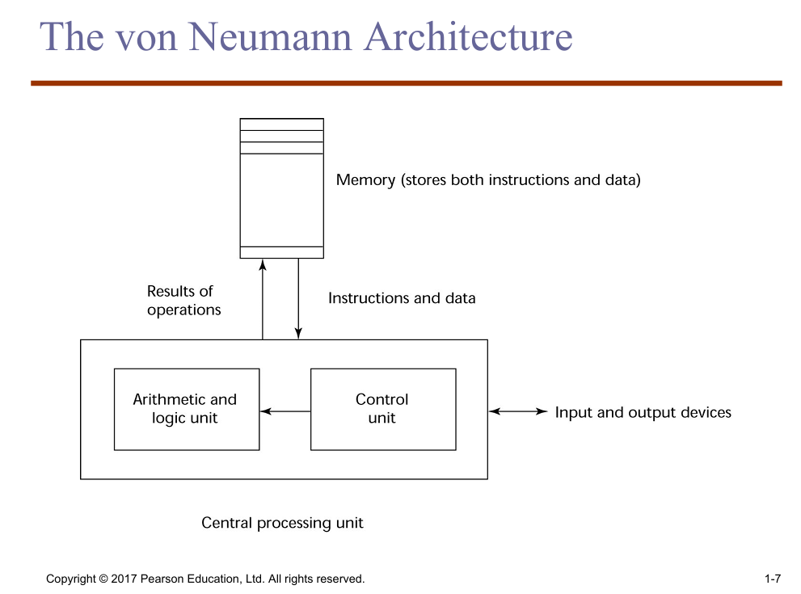
- Von Neumann Bottleneck: The speed of the connection between memory and CPU limits overall performance — this is the primary speed constraint in computers. Program instructions often can be executed much faster than the connection speed thus results in a bottleneck.

Programming Methodologies Influences
- 1950s and early 1960s: Simple applications which focus on machine efficiency over human readability.
- Late 1960s: Focus on people efficiency with better readability and control structures (structured programming) with top-down design and step-wise refinement.
- Late 1970s: Shift from process-oriented to data-oriented approaches (data abstraction).
- Middle 1980s: Emergence of object-oriented programming (data abstraction + inheritance + polymorphism).

Programming Paradigms and Their Features
A programming paradigm is a style or approach to programming that determines how programs are designed and structured. The major programming paradigms are:
Language Categories
- Imperative: Programs are written as a sequence of commands that change the program's state. Central features include variables, assignment statements and iteration. It focuses on how a task should be performed. It includes languages that support OOPs, scripting and visual programming.
Examples: C, Java, Perl.
- Declarative: A programming paradigm that focuses on what the program should accomplish rather than how it should be done. The system determines the execution process itself. It is further classified into functional and logic programming paradigms.
- Functional: Computations are performed by applying functions to given parameters. It emphasizes recursion and mathematical functions.
Examples: LISP, Scheme, F#
- Logic: Rule-based languages where rules and facts are specified in no particular order. The programmer specifies relationships with rules and the system derives the solution.
Example: Prolog
- Markup/programming hybrid: Markup languages extend with some programming capabilities. It is mainly used for web applications and document transformations. Examples: JSTL, XSLT.

Imperative Programming | Declarative Programming
Describes how to perform a task. | Describes what result is desired.
Uses loops, variables, and assignments. | Uses expressions, queries, or built-in operations.
Programmer controls the execution flow. | Execution details are handled by the language/system.
Usually longer and more detailed code. | Code is usually shorter and easier to read.
Examples: C, Java, PHP (procedural style). | Examples: SQL, XSLT, Prolog

Example
Suppose we have a list of participants and want to extract only their names.

Imperative Style (PHP)
$participantList = [1 => 'Peter', 2 => 'Henry', 3 => 'Sarah'];
$firstNames = [];
foreach ($participantList as $id => $name) {
$firstNames[] = $name;
}
Explanation:
The programmer explicitly specifies each step: create an array, iterate through the list, and add each name to the new array.

Declarative Style (PHP)
$firstNames = array_values($participantList);
Explanation:
The programmer specifies the desired result (retrieve all values from the array) without describing the iteration process. The language handles the implementation details.

Implementation Methods
- Compilation: Translates programs into machine language, includes JIT systems. It has slow translation time but faster in execution. Suitable for large commercial applications.
- Pure Interpretation: Programs are interpreted by another program known as interpreter. Suitable for small programs where efficiency is not critical.
- Hybrid Implementation Systems: Combines compilation and interpretation. Suitable for small to medium systems where efficiency is secondary.
Compilation Process (Phases)
- Lexical analysis: Converts characters in source program into tokens( lexical units ).
- Syntax analysis: Analyzes tokens according to the language grammar and builds a parse tree (syntax tree).
- Semantics analysis: Checks the program for meaning and consistency while generating intermediate code.
- Code generation: Produces machine code.
- Linking and loading: Combines object code with required libraries and loads the executable program into memory for execution.
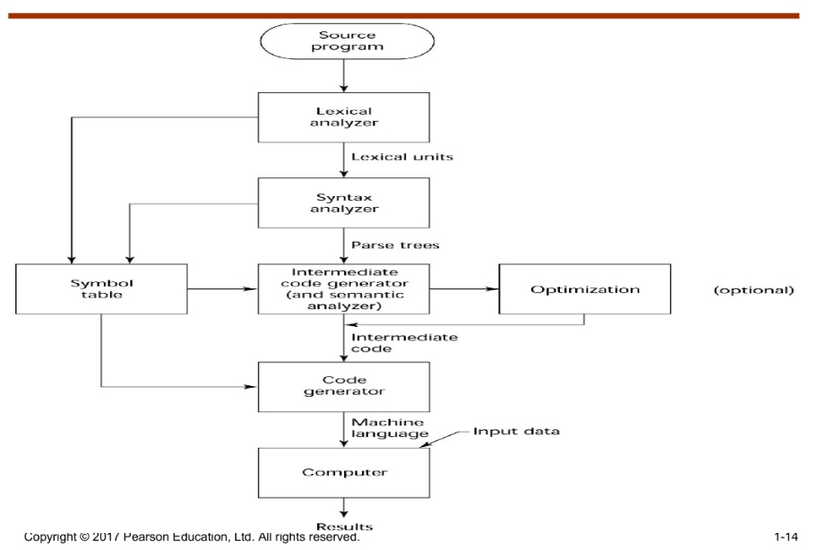

Pure Interpretation
Programs are interpreted by another program requiring no translation known as interpreter. Suitable for small programs where efficiency is not critical.
- Easier implementation: Compared to compiled programs, its easier to implement and debug.
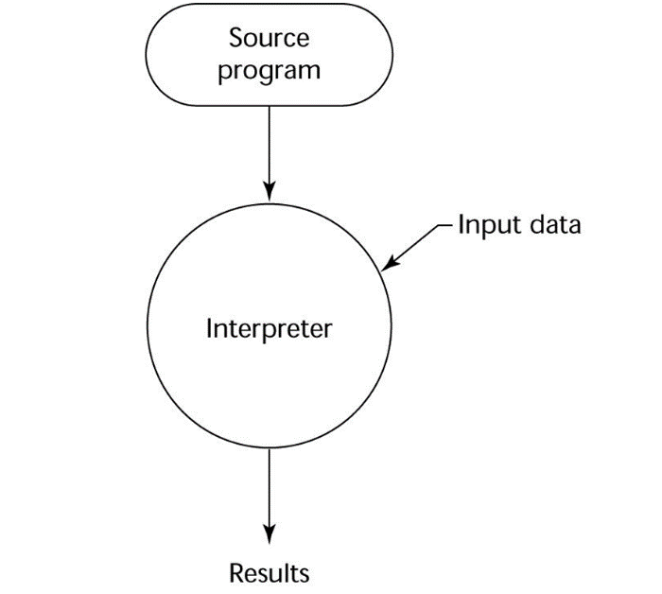
- Slower execution: It is 10-100 times slower than compiled programs requiring more space.

Hybrid Implementation Systems
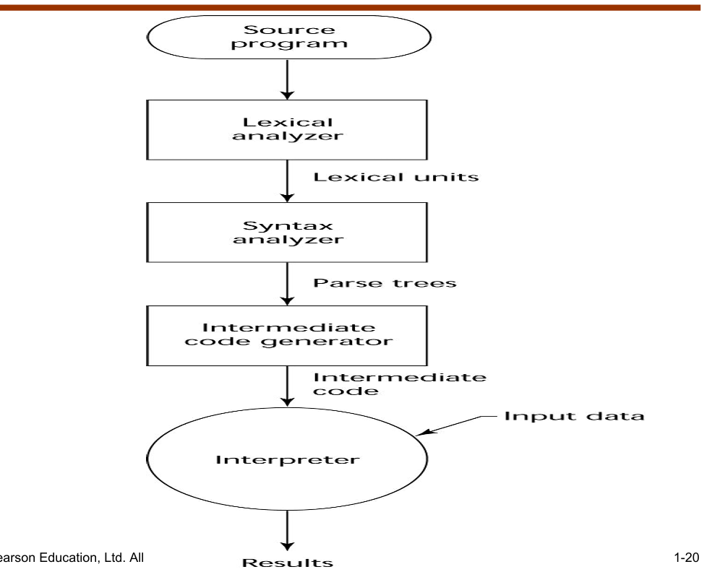
- A compromise between compilation and interpretation. A high-level language program is translated to an intermediate language that allows easy interpretation. Faster than pure interpretation.

Just-in-Time (JIT) Implementation Systems
Intermediate language: Programs are first translated to an intermediate language, then compiled to machine code at runtime. Machine code version is cached for reuse on subsequent calls. In essence, JIT are delayed compiler that improve execution speed while avoiding full pre-compilation. JIT systems are widely used in Java and .NET languages.
Preprocessors
A preprocessor processes a program immediately before the program is compiled to expand embedded preprocessor macros (instructions)
Example: C Preprocessor, which handles:
- #include — inserts content of another file
- #define — defines constants or macros
Programming Environments
- A collection of tools used in software development. Examples include UNIX and Microsoft Visual Studio.NET (for building Web and non-Web applications in any .NET language)

Lecture 2: Models of Computation & Language Attributes
Model of Computation
A model of computation describes how the output of a mathematical function is computed given an input. It organizes units of computations, memories, and communications.
Categories of Models
- Sequential Model:
  - Description: Instructions are executed one after another. While branches may exist in program, each instruction follows from the previous one.
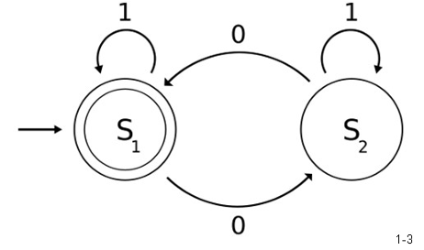
Examples:
    - FSM (Finite State Machine)
    - PDA (Pushdown Automaton)
    - TM (Turing Machine)

- Functional Model:
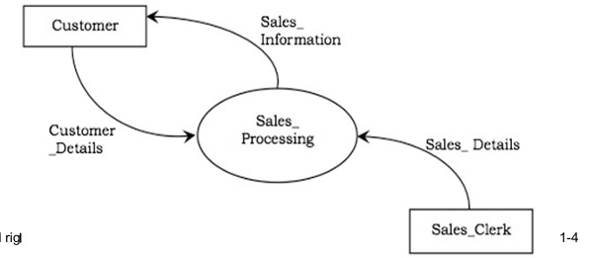
  - Description: A structured representation of functions within a system or subject area.
Examples:
    - Lambda calculus
    - Abstract rewriting systems
    - Combinatory logic

- Concurrent Model:
  - Description: Describes a process where multiple programs or threads are managed by one computing system through alternating timeshared slices.
  - Examples:
    - Actor model
    - Cellular automaton
    - Kahn process networks
Lambda Calculus
- Description: A formal system in mathematical logic for expressing computation based on function abstraction and application using variable binding and substitution. It was introduced by Alonzo Church in the 1930s, it is a universal model of computation that can simulate any Turing machine.
- Components:
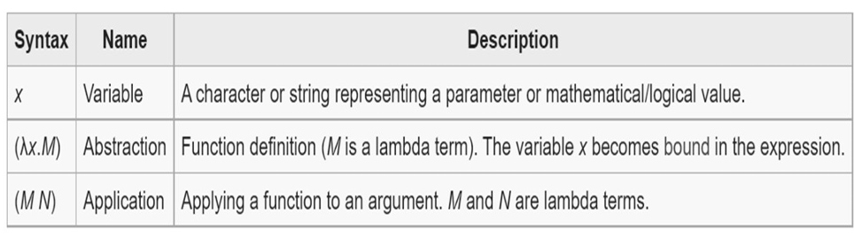
  - Construction of lambda terms o Performing reduction operations

Every function in Python, Java, or any language can be expressed as a lambda term. Closures, higher-order functions, and anonymous functions all trace back to lambda calculus.

Actor Model
- Description: A mathematical model of concurrent computation that treats an actor as the universal primitive of concurrent computation. In response to a message, an actor can make local decisions, create more actors, send messages, and determine how to respond to the next message received. Each actor is an independent computational unit with its own private state and can only affect each other indirectly through messaging.

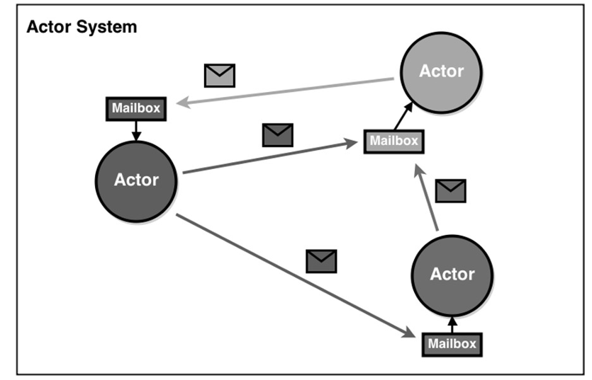

General Attributes of a Good Language
A well-designed programming language should have the following 8 attributes. These attributes are essential for evaluating and selecting programming languages suitable for specific tasks and environments.
Attribute | What it Means
Clarity, Simplicity & Unity | Provides both a framework for thinking about algorithms and a means of expressing those algorithms.
Orthogonality | Every combination of language features are meaningful and consistent. No surprising or illegal combinations.
Naturalness | Program structure should naturally reflect the logical structure of the algorithm being implemented.
Support for Abstraction | Program data and structures should reflect the problem being solved while hiding unnecessary detail.
Ease of Verification | It should be easy to verify (prove or check) that a program correctly performs its intended function.
Programming Environment | It should have strong external tooling support like debuggers, IDEs, libraries, compilers etc.
Portability | Programs written in the language should be easily transferable to different computer systems.
Cost of Use | Overall expense involved in using a language should minimise including program execution , translation, creation and long-term maintenance cost.

Currying
Currying converts a function that takes multiple arguments into a sequence of functions each taking a SINGLE argument. In lambda calculus, all functions take exactly one argument. Multi-argument functions are expressed by returning another function.

Example — Addition function (curried):
ADD = lambda x . lambda y . x + y

ADD 3 4
= (lambda x . lambda y . x+y) 3 4
= (lambda y . 3+y) 4
= 3+4
= 7

Church Numerals — Numeric Increment
Numbers are represented as higher-order functions in lambda calculus (Church numerals):
0 = lambda f . lambda x . x (apply f zero times)
1 = lambda f . lambda x . f x (apply f once)
2 = lambda f . lambda x . f(f x) (apply f twice)
3 = lambda f . lambda x . f(f(f x)) (apply f three times)

The Successor (increment) function adds 1 to any Church numeral:
SUCC = lambda n . lambda f . lambda x . f(n f x)

Verify: SUCC 1 = ?
= (lambda n . lambda f . lambda x . f(n f x)) 1
= lambda f . lambda x . f(1 f x)
= lambda f . lambda x . f(f x)
= 2 [CORRECT]

Lecture 3: Lexical and Syntax Analysis
Introduction
Lexical analysis is the first phase of a compilation responsible for reading the source program and converting it into a meaningful sequence of tokens. Nearly all syntax analysis is based on a formal description of the source language, typically using Backus-Naur Form (BNF).
Lexical Analysis
• Main Task: Converts characters in source program and group them into tokens( lexical units ). • Secondary Tasks:
- Skip comments and whitespaces.
- Correlate error messages with the source program (e.g., line number of the error).
The Process:
- The scanner reads the source code character by character.
- It identifies lexemes (sequences of characters) that match specific patterns.
- It removes unnecessary elements like whitespace and comments.
- It produces a token for each identified lexeme and stores identifier details in a symbol table.
Example: Consider the input statement: count = 123 The lexical analyzer processes this as follows:
- Lexeme count: Matches the pattern for an identifier (a letter followed by letters/digits). It returns the token identifier.
- Lexeme =: Matches the pattern for an assignment operator. It returns the token assg_op.
- Lexeme 123: Matches the pattern for an integer constant (a sequence of digits). It returns the token integer_const.
The final output is a sequence of token-attribute pairs: (identifier, "count"), (assg_op, =), (integer_const, 123).
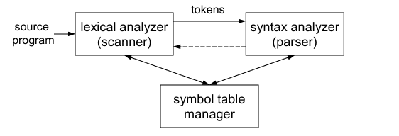

Implementing Lexical Analyzers
There are three primary ways to build a lexical analyzer, varying in ease and efficiency:
- Using a scanner generator (e.g., lex or flex):
  - Automatically generates a lexical analyzer from a high-level description of tokens. It is easiest to implement, but least efficient.
- Programming in high-level language such as C:
  - It is manually programmed using the I/O facilities of the language. It is intermediate in ease and efficiency.
- Writing it in assembly language:
  - Input is managed expicitly. Hardest to implement but provides the most efficient performance.

Lexical Analysis Terminology
- Token: A name for a set of input strings with related structure (e.g., “identifier,” “integer constant”).
- Pattern: A rule describing the set of strings associated with a token (e.g., “a letter followed by zero or more letters, digits, or underscores”).
- Lexeme: The actual input string that matches a pattern (e.g., _{count}).
Attributes for Tokens
If multiple lexemes match the pattern for a token, the scanner must indicate the actual lexeme that matched. This information is given using an attribute associated with the token.
Example:
plaintext Copy code
Program statement: count = 123 Token-attribute pairs:
⟨identifier, pointer to the string “count”⟩
⟨assg_op, ⟩ ⟨integer_const, the integer value 123⟩
Specifying Tokens with Regular Expressions
- Alphabet: A finite set of symbols.
- String: A finite sequence of alphabet symbols.
- Language: A (finite or infinite) set of strings.
Regular Operations on Languages:
Regular Expressions (RE) are used to define the patterns for tokens. The lexer uses these patterns to recognize and tokenize the source code. Common operations include Union ( $R∪S$ ), Concatenation $RS$, and Kleene Closure: $R^{*}$
- Union: R ∪ S = { x | x ∈ R or x ∈ S}
- Concatenation: RS = { xy | x ∈ R and y ∈ S}
- Kleene closure: R* = {ε} ∪ R ∪ RR ∪ RRR ∪ ...
Common Regular Expression Definitions
- Letters = [A-Za-z] Digits = [0-9]
- Identifier = letter (letter | digit | '_')*
- Float = digits '.' digits
- Integer_const = digits+
- Keyword = 'if' | 'while' | 'for' | 'return'
- Example RE for identifiers: [A-Za-z][A-Za-z0-9_]* Matches: count, total_sum, x2 (NOT: 2x, _var)

Finite Automata: Used to implement the logic of the scanner.
- Deterministic Finite Automata (DFA): A state machine that transitions between states based on input characters until it reaches a "final state" (indicating a match).
- Longest Match Rule: The scanner should always find the longest possible match. For example, 123.45 should be treated as one num_const rather than an integer, a dot, and another integer.
Finite Automata: An Example
A deterministic finite automaton (DFA) can match patterns such as C-style comments.
Actions on Finding a Match
- Copy lexeme (or other token attribute) to where the parser can access it.
- Save any necessary scanner state so that scanning can resume at right place.
- Return a value indicating the token found.
Introduction to Flex
Flex (Fast Lexical Analyzer Generator) is a tool that generates C code for lexical analyzers( scanner or lexers).
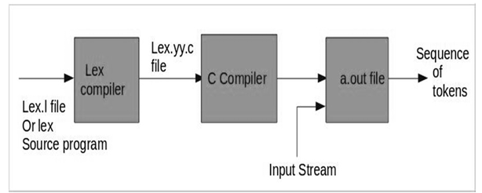
Flex Program Components:
- Definition Section: It contains the declaration of variables, regular definitions, manifest constants enclosed in “%{%}” brackets
- Rules Section: It contains series of rules in the form: _{pattern action} enclosed in “%%%%”
- User Code Section: It contains C functions like main() that call yylex() to begin scanning.
Example:
%{
#undef yywrap
#define yywrap() 1
%}

%% [\n] {
printf("Hello World\n");
}
%% main() {
yylex(); // calling the rules section }

Chapter 3: Describing Syntax Analysis
Syntax analysis is the second phase of a compilation responsible for determining the grammatical structure of the source code. This phase uses a parser to verify that the sequence of tokens provided by the lexer follows the language's grammar.
Introduction
- Syntax: Defines the form or structure of expressions, statements, and program units.
- Semantics: Defines the meaning of those expressions and statements.
Chomsky Hierarchy: Grammar is classified into four types:
- Type 0: Unrestricted Grammar (Recognized by Turing Machines which can solve any classical problem).
- Type 1: Context-Sensitive Grammar (Accepted by Linear Bound Automata).
- Type 2: Context-Free Grammar (CFG) (Accepted by Push Down Automata).
- Type 3: Regular Grammar (Accepted by Finite Automata).
Context-Free Grammars
It was developed by Noam Chomsky. It is a formal way to describe the syntax of programming languages and is widely used in compiler design. CFG consists of:
- Fundamentals:
  - Non-terminals: Symbols that can be expanded (e.g., <expr>, <stmt>)
  - Terminals: Actual symbols of the language (e.g., a, +, =)
  - Production rules: Rules that define how non-terminals are replaced
  - Start symbol: The initial symbol from which parsing begins
Example Rule: <expr> → <term> + <term>

A parse tree (derivation tree) is a tree representation of how a string is derived from the start symbol using grammar rules.
During compilation, especially in the syntax analysis phase, the compiler:
- Takes source code as input
- Uses CFG rules to check if the code is syntactically correct
- Builds a parse tree based on derivations
- Detect syntax errors (invalid derivations)
- Provide structure for semantic analysis and code generation
Thus, CFG acts as a blueprint for constructing the parse tree.
Example Grammar:
S → id = S
S → S + X | X
X → X * Y | Y
Y → id

Derivation (building a parse tree):
For id = id + id from S.
S ⟹ id = S ⟹ id = S + X ⟹ id = X + Y ⟹ id = Y + id ⟹ id = id + id
Grammar: a finite non-empty set of rules. A start symbol is a special element of the non-terminals of a grammar

1. Recursive vs. Non-Recursive Grammar
Feature | Recursive Grammar | Non-Recursive Grammar
Definition | A grammar where a non-terminal appears on both sides of a production (directly or indirectly). | A grammar where no non-terminal eventually derives a string containing itself.
Language Size | Necessarily produces an infinite language if there are no useless rules. | Produces a finite language.
Example | S -> SaS , S -> b | S -> Aa , A -> b | c
Parsing Use | Often used to describe repeating structures like lists, expressions. | Used to parsesimpler grammars; easy to enumerate all strings.

Types of Recursive Grammars
Based on the nature of the recursion in a recursive grammar, a recursive CFG can be again divided into the following: (General Recursive also)

Aspect | Left Recursive | Right Recursive
Definition | The non-terminal appears at the leftmost position in its own production. Example: A → A α | β | Non-terminal A appears at the rightmost position: A → β | α A
Parse tree growth | Grows to the LEFT side | Grows to the RIGHT side
Associativity | Models LEFT-associative operators: +, -, *, / | Models RIGHT-associative operators: ^ (exponentiation)
Use in LL(1) | Left recursion is problematic for top-down parsers (like recursive descent), because it can lead to infinite recursion. Useful in bottom-up parsers (like LR parsers). | It is fine for top-down parsers (like recursive descent) but can cause deep recursion stack in some cases if the recursion is long.
Example | E -> E + T | T | E -> T ^ E | T

General Recursive:
Non-terminal appears anywhere (left, right, or middle)
Example: S → a S b | ε (S recurses in the middle)
Deterministic vs. Non-Deterministic Grammar
Aspect | Deterministic | Non-Deterministic
Definition | At each parsing step, exactly ONE production rule can be applied | Multiple productions may be possible; parser may need to try alternatives.
Backtracking | No backtracking needed (decisions are deterministic). | Parser must explore alternatives paths through backtrack.
Efficiency | Very efficient — O(n) parsing | Less efficient
Parsers | LL(1), LR parsers work on deterministic grammars | Recursive descent (backtracking) handles non-deterministic
Example | E -> T E'; E' -> +T E' | e | E -> E + E | E * E | id

Ambiguous vs. Unambiguous Grammar
Feature | Ambiguous Grammar | Unambiguous Grammar
Parse Trees | Can generate two or more distinct parse trees for the same string. | Generates exactly one unique parse tree for any valid string.
Operator Logic | Does not naturally account for operator precedence or associativity. | Uses hierarchical levels to enforce precedence and associativity.
Example | E -> E + E | id  (id + id) + id  id + (id + id)  Result: two distinct parse trees → grammar is ambiguous. | E → E + T | T  T → id  String: id + id + id  Only one parse tree because + is left-associative by construction:
Parsing Difficulty | Harder to parse deterministically; may require backtracking or more complex algorithms. | Easier to parse deterministically, suitable for LL(1) or LR parsers.
Ambiguity creates problems during the syntax analysis (parsing) phase of compilation because the compiler cannot determine a unique structure for the expression and may generate different intermediate codes. So program correctness can not be guaranteed. Thus ambiguity must be removed before code generation.
Example: E → E + E| E * E | id
(id + id) + id OR id + (id + id)
Removal of Ambiguity in Grammar:s
Ambiguity in grammar can be removed based on two important properties:
1. Precedence
When different operators are used, ambiguity is resolved by considering the precedence of operators. The key characteristics are:
- The level at which a production appears determines the priority of the operator.
- In a parse tree, nodes closer to the root represent lower priority operators while nodes closer to the leaves represent higher priority operators.
2. Associativity
When operators of the same precedence appear in a production, associativity is used to resolve ambiguity:
- If associativity is left to right, left recursion is used in the production. The parse tree becomes left recursive and grows toward the left. Operators such as *+, −, , / are left associative.
- If associativity is right to left, right recursion is used in the production. The parse tree becomes right recursive and grows toward the right. The operator ^ is right associative.
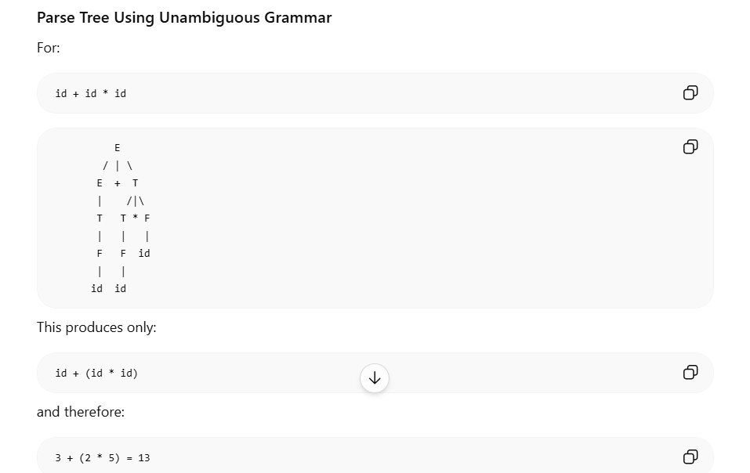
Thus, by properly applying precedence and associativity rules, ambiguity in grammar can be effectively removed. Multiplication (*) has higher precedence than Addition (+).

Chapter 4: Parser using Pushdown Automata (PDA)
Pushdown Automata (PDA)
A Pushdown Automaton (PDA) is an extension of a finite automaton that includes an extra memory structure called a stack. This stack allows the PDA to recognize context-free languages.
Formal Definition
A Pushdown Automaton can be defined as:
PDA = (Q, Σ, Γ, q₀, Z, F, δ)
Where:
- Q is the set of states
- Σ is the set of input symbols
- Γ is the set of stack (pushdown) symbols, which can be pushed to or popped from the stack
- q₀ is the initial state
- Z is the initial stack symbol (initially present in the stack)
- F is the set of final (accepting) states
- δ is the transition function defined as:
δ : Q × (Σ ∪ ε) × Γ → Q × Γ*
Top-Down Parsing using PDA
Transitions for Top-Down Parsing:
- Push the Start Symbol: Push the start symbol 'S' into the stack.
- Pop and Push Production: Pop the non-terminal on the left-hand side of the production at the top of the stack and push its right-hand side string.
- Match and Pop: If the top symbol of the stack matches the input symbol, pop it.
- Final State: If the input string is fully consumed and the stack is empty, go to the final state 'F'.
P: S → S+X | X, X → X*Y | Y, Y → S | id
Example: Parsing "x+y*z"
S ⇒ S + X ⇒ X + X ⇒ Y + X ⇒ id + X ⇒ id + X * Y ⇒ id + Y * Y ⇒ id + id * Y
⇒ id + id * id
Bottom-Up Parsing using PDA
Transitions for Bottom-Up Parsing:
- Push Input Symbol: Push the current input symbol into the stack.
- Replace with Production: Replace the right-hand side of a production at the top of the stack with its left-hand side.
- Match and Pop: If the top of the stack element matches the current input symbol, pop it.
- Final State: If the input string is fully read and only the start symbol 'S' remains in the stack, pop it and go to the final state 'F'.
Example: Parsing "x+y*z"
id + id * id , Y + id * id (Y → id) , X + id * id (X → Y)
S + id * id (S → X) , S + Y * id (Y → id) , S + X * id (X → Y)
S + X * Y (Y → id) , S + X (X → X * Y) , S (S → S + X)

Chapter 3: Describing Syntax Analysis
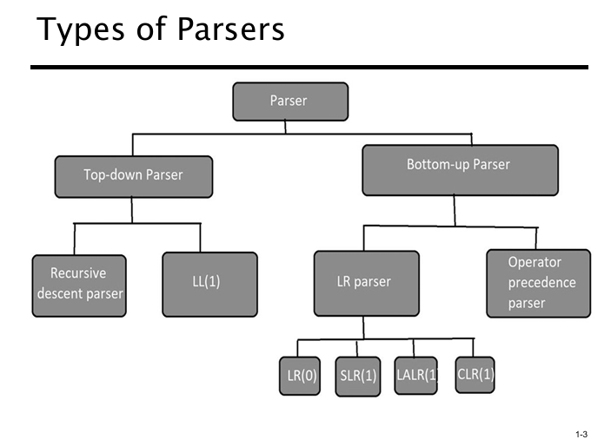
Syntax analysis is the second phase of a compilation responsible for determining the grammatical structure of the source code. This phase uses a parser to verify that the sequence of tokens provided by the lexer follows the language's grammar.
Parse Tree: A hierarchical representation of a derivation of input strings using grammar rules.
Types of Parsers:

- Top-Down Parser:
  - Generates parse for the given input string using grammar productions by expanding the non-terminals.
  - Starts from the start symbol of the grammar and works down to the terminal symbols (the input string).
  - Uses Leftmost Derivation (LMD)
a. Recursive Descent Parser:
  - Also known as the brute force parser or the backtracking parser.
  - Generates the parse tree using brute force and backtracking.
  - S aAb | aBb ; A cx | dx ; B xe
  - Left recursion is removed from a grammar because it can cause infinite recursion (loops) in top-down parsers, preventing them from parsing the input correctly.
  - Non-Recursive Descent or LL(1) Parser:
- A non-recursive descent parser that uses a parsing table and a stack to predict the correct production without backtracking.
- The first L stands for scanning input from Left to right.
- The second L stands for Leftmost derivation.
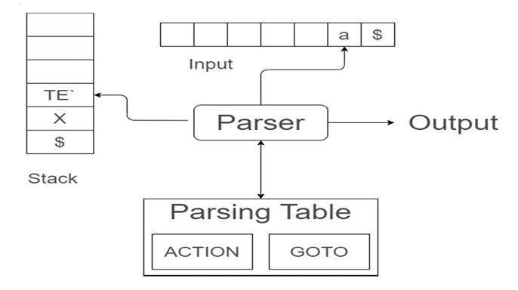
- The 1 represents using one look-ahead token.

- Bottom-Up Parser:
  - Generates the parse tree for the given input string by compressing or reducing them back to non-terminals.
  - Starts from non-terminals and ends on the start symbol.
  - Uses the reverse of the Rightmost Derivation (RMD)
Example of Bottom-Up Parsing:
Grammar: S aABe , A Abc | b , B d
- Input: abbcde$
- Start with A -> b
- Expand A -> Abc
- Expand B -> d o
- Finally, expand S -> aABe
- Final string: _{abbcde}
  - LR Parser:
- Reads input left to right and builds the tree from the leaves up to the top-level productions. Includes variants like LR(0), SLR(1), LALR(1), and CLR(1).

  - Operator Precedence Parser:
- Generates the parse tree from given grammar and string with the condition that two consecutive non-terminals and epsilon never appear on the righthand side of any production. E => E + E / E * E / id

Pre-processing for Top-down Parsing
To use a top-down parser effectively, the grammar must often be modified to remove Left Recursion, which can cause infinite loops in recursive descent parsers.
Example of Removal:
- Original (Left Recursive E → E + T ∣ T
- Modified (Non-Recursive):
  - E → TE′
  - E′ → +TE′ ∣ ϵ
Bison
- Bison: A parser generator that is part of the GNU Project.
- Bison Variants: Includes various versions and adaptations for different use cases.
- Bison File (.y): Contains the grammar rules and code sections.
Bison is a tool used to generate a C function called yyparse() from a high-level specification.
Language | Tool
Java | JavaCC, CUP
Haskell | Happy
Python | PLY
C# | Grammatica
Multi-Language | ANTLR

Example of a Bison File:
%{
#include <stdio.h>
%}
%%
e : '(' e '+' e ')' | '(' e '*' e ')' | 'x' | 'y'
%%
int yylex() {
char c = getchar();
if (c == '\n') return 0; else return c;
} void main() { yyparse(); }
Executing a Bison File:
- Generates a C source file (e.g., somename.tab.c) and a header file (somename.tab.h) from a .y specification file containing context-free grammar and C actions
- Process: The generated parser reads tokens and determines the grammatical structure based on the provided grammar.

Differentiate Flex vs Bison

Aspect | Flex (Lexer) | Bison (Parser)
Full Name | Fast Lexical Analyzer Generator | GNU Parser Generator (Yacc-compatible)
Purpose | Lexical analysis — tokenisation of input | Syntax analysis — parsing grammar rules
Input taken | Raw characters from source file | Token stream produced by Flex
Output produced | Sequence of tokens for the parser | C function yyparse() that matches grammar
File extension | .l or .lex | .y
Main function | yylex() — called to get next token | yyparse() — called to start parsing
Based on | Regular expressions / DFA (Finite Automata) | Context-free grammar / LR parsing (PDA)
Grammar type | Recognises regular languages | Recognises context-free languages
How defined | Pattern-action pairs using regex | BNF-style grammar productions with C actions
Tool relationship | Feeds tokens TO Bison | Calls yylex() FROM Flex to get tokens

Combined workflow:
Source Code
|
[Flex .l file] --> Tokens
|
[Bison .y file] --> Parse Tree / Actions

Chapter 3: Describing Semantics
Introduction to Semantics
- Syntax: The form or structure of the expressions, statements, and program units. Semantics: The meaning of the expressions, statements, and program units.
Semantics and syntax together define a language.
The Need for Semantics
- Programmers need to understand what statements mean.
- Compiler writers need precise definitions of language constructs.
- Correctness proofs for programs require clear semantics.
- Compiler generators need detailed semantic rules.
- Language designers can identify ambiguities and inconsistencies.
Attribute Grammars
Attribute Grammars (AGs) extend Context-Free Grammars (CFGs) by attaching semantic information to parse tree nodes.
Uses of AGs:
- Used for Static semantics specification.
- Compiler design (static semantics checking).
Semantic Analysis
Semantic Analysis ensures that the declarations and statements in a program are semantically correct. It consists of a collection of procedures invoked by the parser and uses the syntax tree generated in the previous phase along with the symbol table to check the consistency of code.
Key Aspects of Semantic Analysis:
- Type Checking: Ensures that data types are used in a consistent way with their definitions.
- Label Checking: Ensures that labels and their references are correctly used in the program.
- Flow Control Checking: Ensures that control structures are used properly (for example, no break statement outside a loop).
Example:
float x = 10.1; float y = x * 30;
The integer ₃₀ is type-casted to _{float 30.0} before multiplication by the semantic analyzer.
Semantic Errors
Semantic analyzers recognize the following errors:
- Type mismatch.
- Undeclared variables.
- Misuse of reserved identifiers.
Static vs Dynamic Semantics
- Static Semantics: Static semantics are checked at compile time. They include rules related to variable declarations, type checking, and other compile-time constraints.
- Dynamic Semantics: Dynamic semantics are checked at runtime. They define the meaning and behavior of program units such as expressions and statements during program execution.
Operational Semantics: Describes the meaning of a program by executing its statements on a machine, either real or simulated. The state changes in the machine (memory, registers, etc.) define the statement's meaning.
For high-level languages, a virtual machine is required to use operational semantics.
Uses:
- Used for describing program execution in language documentation and textbooks.
- Teaching and understanding the behavior of programming languages through step-by-step execution.
Types:
- Natural operational semantics.
- Structural operational semantics.
Denotational Semantics: Denotational semantics is based on recursive function theory and is the most abstract method for describing semantics.
Development Process:
The process of building a denotational specification for a language is:
- Define a mathematical object for each language entity.
- Define a function that maps language entities to their corresponding mathematical objects.
- The meaning of language constructs is defined solely by the values of program variables.
Evaluation:
- Can be used to prove the correctness of programs
- Provides a rigorous way to understand programs.
- Helps in language design.
- Used in compiler generation systems.
Axiomatic Semantics: Axiomatic semantics is based on formal logic (predicate calculus) and was originally developed for formal program verification.
Key Concepts:
- Assertions: Logical expressions about program variables.
- Precondition: An assertion before a statement.
- Postcondition: An assertion after a statement.
- Weakest Precondition: The least restrictive precondition that guarantees the postcondition.
Form: {P} statement {Q}
Example: a=b+1{ a > 1 }
- One possible precondition: {b > 10}
- Weakest precondition: {b > 0}
Evaluation:
- Developing axioms or inference rules for all language statements is difficult.
- Can be used to prove the correctness of programs
- Less useful for language users and compiler writers.
- Its useful in describing programming language meaning is limited for practical implementation.

Chapter 5: Names, Bindings, and Scopes
Names
Design Issues for Names:
- Are names case sensitive?
- Are special words reserved words or keywords?
Length:
- Very short names may lack descriptive power.
- Examples:
  - C99: No limit, but only the first 63 characters are significant; external names are limited to maximum of 31 characters.
  - C# and Java: No limit, all characters are significant.
  - C++: No limit, but some implementations may impose one.
Special Characters:
- PHP: Variables must start with $.
- Perl: Variable names begin with special characters that specify the variable type ($, @, %).
- Ruby: Variables starting with @ are instance variables while those with @@ are class variables.
Case Sensitivity:
- A disadvantage of case sensitivity is reduced readability because similar-looking names may represent different identifiers.
- C-based languages are case sensitive.
- Predefined names in C++, Java, and C# use mixed case (e.g., IndexOutOfBoundsException).
Special Words:
Special words improve readability by delimiting or separating statement clauses.
- Keyword: A word that is special only in certain contexts.
- Reserved Word: A special word that cannot be used as a user-defined name.
- Problem: Too many reserved words can cause collisions (e.g., COBOL has 300 reserved words).
Variables: A variable is an abstraction of a memory cell. Variables can be characterized as six tuple of attributes:
- Name: An identifier used to refer to the variable. (Not all variables are explicitly named)
- Address: The memory location associated with the variable.
  - A variable may have different addresses at different times or places in a program.
  - Aliases: Different variable names that refer to the same memory location, created using pointers or references. Aliasing can reduce readability and make programs harder to understand.
- Type: Defines the range of values and operations allowed for the variable. In floating-point, it also determines precision.
- Value: The contents of the memory location associated with the variable.
  - l-value: The address of the variable. o r-value: The value of the variable.
- Lifetime: The period during which a variable is bound to a memory cell.
- Scope: The range of statements over which the variable is visible.
- Abstract Memory Cell: The conceptual memory location (one or more physical cells) associated with a variable.
The Concept of Binding
Binding: Binding is a association between an entity and an attribute (e.g., between variable and its type or value, operation to symbol).
Binding Time: Time at which binding takes place. Possible binding times are:
- Language design time: Binding of basic language constructs such as operator symbols to operations (e.g., + defined as addition).
- Language implementation time: Binding of language features to their internal representations such as the representation of the float or int data types.
- Compile time: Bind a variable to a type in C or Java.
- Load time: Bind a static variable in C or C++ to a memory cell.
- Runtime: Bind non-static local values or variables to a memory cell during program execution.

Static Binding
Static binding (early binding) occurs when the association between a program element and its attribute is determined before program execution usually at compile time.
Example:
int add(int a, int b) {
return a + b;
}
int main() {
int x = add(2, 3); // Function call resolved at compile time
}
Here, the call to add() is bound to the function during compilation.

Dynamic Binding
Dynamic binding (late binding) occurs when the association is determined during program execution (runtime).
Example (C++):
class A {
public:
virtual void display() {
cout << "A";
}
};

class B : public A {
public:
void display() {
cout << "B";
}
};

A* ptr = new B();
ptr->display(); // Resolved at runtime}
The function called depends on the actual object (B) at runtime.

Static Binding | Dynamic Binding
Occurs at compile time. | Occurs at runtime.
Faster execution. | Slightly slower due to runtime lookup.
Function to call is known before execution. | Function is selected during execution.
Does not support runtime polymorphism. | Supports runtime polymorphism.
Example: Normal function calls in C. | Example: Virtual functions in C++.

Which One is Used in C for Function Calls and Why?
C uses static binding for normal function calls because the compiler knows the exact function to execute at compile time. This allows efficient direct calls with no runtime overhead.
Reason:
- C has no built-in support for virtual functions or runtime polymorphism.
- Function targets are known during compilation
- Static binding results in faster execution and lower overhead because no runtime method lookup is required.
Example:
void greet() {
printf("Hello");
}
int main() {
greet(); // Statically bound
}
The compiler knows exactly which function greet() refers to so the binding is done at compile time.
Explicit/Implicit Declaration:
- Explicit Declaration: Program statement used to declare variable types.
- Implicit Declaration: Default mechanism for specifying variable types through conventions rather than declaration.
  - Advantages: Increased writability (faster and less verbose coding).
- Disadvantages: Reduced reliability (more potential for type-related errors and harder debugging).

Some languages use type inferencing to determine variable types based on context like JavaScript, C#, Perl , Visual Basic 9.0+, ML, Haskell, F#.
Bindings and Lifetime
Lifetime: The period during which a variable is bound to a memory cell
Categories of Variables by Lifetimes:
- Static Variables:
Storage is bound to memory cells before program execution begins and remains fixed throughout execution.
Advantages:
  - Efficient access (no runtime allocation overhead)
  - Value is retained between function calls
Disadvantages:
  - Lack of flexibility
  - Not suitable for recursive structures requiring separate activation records
- Stack-Dynamic Variables:
Storage bindings are created when declarations are elaborated during execution and destroyed when the subprogram ends.
Advantages:
  - Supports recursion
  - Efficient use of memory (automatic allocation/deallocation)
Disadvantages:
  - Runtime overhead of stack management
  - Values do not persist between calls
  - Access can be less efficient than static variables
- Explicit Heap-Dynamic Variables:
Memory is allocated and deallocated explicitly by the programmer during execution (e.g., using malloc, new, delete).
Advantages:
  - Flexible dynamic memory management
  - Useful for dynamic data structures (linked lists, trees)
Disadvantages:
  - Risk of memory leaks and dangling pointers
  - Slower due to manual management
- Implicit Heap-Dynamic Variables:
Memory is allocated and deallocated automatically by the system based on assignment or usage.
Advantages:
  - Very flexible and easy to use
  - No need for explicit memory management
Disadvantages:
  - Inefficient compared to other types
  - Loss of error detection and control
  - High runtime overhead
Scope: The range of statements over which a variable is visible. The scope rules of a language determine how references to names are associated with variables
Types of Variables:
- Local Variables: Declared inside a function or block and accessible only within it.
- Nonlocal Variables: Visible in the unit but not declared there.
- Global Variables: Variables declared outside all functions and accessible throughout the program.

Static Scope (Lexical Scope)
A scoping mechanism where a variable reference is resolved by examining the program’s lexical (textual) structure.
- Search process: Look for the declaration:
  - In the local scope.
  - Then in increasingly larger enclosing scopes.
  - Stop when a matching declaration is found.
- Scope is determined at compile time.
- Uses static (lexical) parent relationships
- Supports nested functions and blocks
- Examples: C, C++, Java, Python, JavaScript, Scheme, etc.
Blocks: A method of creating static scopes inside program units from ALGOL 60.
void sub() { int count; while (...) { int count; // inner block variable count++; ... } … } Legal in C/C++ but error-prone in Java/C#.
Declaration Order
The rule that determines variables can be declared at any portion of the program before it is used. In languages like C, C++, Java, and C#, scope typically extends from declaration to end of block.

Global Scope
- Supported in C, C++, PHP, and Python.
- These languages allow variable declarations to appear outside function definitions (global variables)
- In C and C++:
  - Declaration: Specifies attributes of a variable.
  - Definition: Allocates memory.
- Variables declared outside functions
- Accessible throughout the program
Feature | Static Scope (Lexical Scope) | Global Scope
Meaning | Scope is determined by the position of variables in the program code | Variables are declared in the outermost scope and accessible everywhere
Binding time | Resolved at compile time | Exists for the entire program execution
Access | Inner functions can access variables from their own and outer blocks | Variables can be accessed from any part of the program
Lifetime | Its lifetime depends on block/function structure (created and destroyed with blocks) | Exists throughout program runtime
Example | Variables inside nested functions in languages like C/JavaScript (lexical scoping) | A variable declared outside all functions (e.g., global variable in C/C++)

Scope Example:

x = 10 // global

function sub1() {

x = 20

sub2()

}

function sub2() {

print(x)

}

main() {

sub1()

}
Under static (lexical) scoping, sub2 uses the nearest enclosing global binding of x, so it prints 10.
Under dynamic scoping, sub2 uses the caller’s environment (sub1 where x = 20), so it prints 20.

Referencing Environments
- The referencing environment of a statement consists of all the names that are visible within that statement.
- In static-scoped languages, the referencing environment includes local variables and all visible variables declared in enclosing scopes.
- In dynamic-scoped languages, the referencing environment includes local variables and all visible variables in active subprograms (a subprogram whose execution has begun but has not yet completed).
Named Constants
- A named constant is an identifier whose value remains unchanged after it is bound to storage.
- Advantages: readability and modifiability.
- Used to parameterize programs by replacing literal values with meaningful names.
- The binding of values to named constants can be:
  - Static (called manifest constants).
  - Dynamic.
- C++ and Java: Allow expressions of any kind; named constants are dynamically bound.
- C#:
  - const → value is bound at compile time (static binding).
  - readonly → value is dynamically bound. (typically at runtime during object construction)

Chapter 6: Data Types
Introduction
A data type defines a collection of data objects and a set of predefined operations on those objects.
- Descriptor: Collection of the attributes of a variable.
- Object: Represents an instance of a user-defined (abstract data) type.
- Design issue for all data types: What operations are defined and how are they specified?
Primitive Data Types
Primitive data types are basic built-in types provided by a programming language that are not defined in terms of other types. Some are directly supported by hardware, while others need minimal software support for implementation.
Primitive Data Types: Integer
Integers are almost always an exact reflection of the hardware making their mapping trivial. Languages like Java provide several signed integer sizes (e.g., byte, short, int, long).
Primitive Data Types: Floating Point
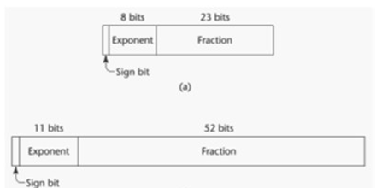
Floating-point types model real numbers but only as approximations. Languages for scientific use typically support at least two floating-point types (e.g., float and double). They often follow the IEEE Floating-Point Standard 754.

Primitive Data Types: Complex
Some languages, such as C99, Fortran, and Python, support a complex type, where each value consists of two floats (real and imaginary parts). Example in Python: _{(7 + 3j)}.
Primitive Data Types: Decimal
Decimals are crucial for business applications like handling money. They store a fixed number of decimal digits in coded form (BCD). The main advantage is accuracy, but they have a limited range and waste memory. COBOL and C# offer decimal types.
Primitive Data Types: Boolean
The simplest data type with a range of values consisting of two elements: "true" and "false".
Booleans can be implemented as bits or bytes, with the primary advantage being readability.
Primitive Data Types: Character
Characters are stored as numeric codings with ASCII being the most common. Unicode supports a broader range of characters from most natural languages and is used in Java, C#, JavaScript etc.
Character String Types
Character strings are sequences of characters.
Design issues include whether they are primitive types or special arrays, and whether their length should be static or dynamic.
Character String Types Operations
Typical operations on character strings include:
- Assignment and copying
- Comparison
- Catenation
- Substring reference
- Pattern matching
Character String Type in Certain Languages
Different languages handle character strings differently:
- C and C++: Not primitive, use _{char} arrays and library functions.
- Java: Primitive via the _{String} class.
- Perl, JavaScript, Ruby, Python and PHP: Provide built-in pattern matching using regular expressions.
Character String Length Options
- Static Length: Used in COBOL and Java's String class, where the length is fixed after creation.
- Limited Dynamic Length: (e.g., C and C++, uses a special character to indicate the end of a string rather than maintaining length)
- Dynamic Length: Used in SNOBOL4, Perl, and JavaScript, where strings can grow or shrink dynamically with no predefined maximum length.
Character String Type Evaluation
Character strings improve writability. As a primitive type with static length, strings are inexpensive to provide. Dynamic length strings offer flexibility but at a higher cost requiring additional storage and processing overhead.
Character String Implementation
- Static Length: Compile-time descriptor.
- Limited Dynamic Length: May need a run-time descriptor for length. (but not in C/C++)
- Dynamic Length: Requires a run-time descriptor as allocation/deallocation is the biggest implementation problem.
Compile- and Run-Time Descriptors
- Compile-Time Descriptor: Used for static strings.
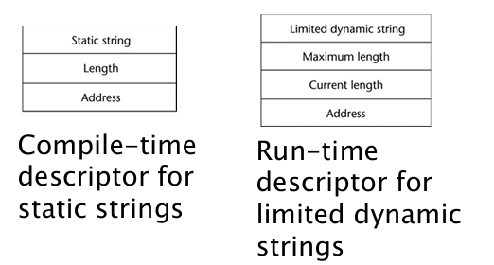
- Run-Time Descriptor: Used for limited dynamic strings.

User-Defined Ordinal Types
Ordinal types are those where the range of possible values can be easily associated with the set of positive integers (e.g., integer, _{char}, _{boolean} in Java).
Enumeration Types
Enumeration types define all possible values as named constants. For example, in C#: _{enum} days {mon, tue, wed, thu, fri, sat, sun}.
Design issues include:
- Whether an enumeration constant can appear in more than one type definition and how its type is checked.
- Whether enumeration values are coerced to integers.
- Whether integer values can be coerced into enumeration types.
Evaluation of Enumerated Type
- Improves readability (e.g., using red ‘description’ instead of numeric codes).
- Improves reliability by allowing compiler checks:
- Prevents assignment outside defined range.
- C# and Java 5.0 provide stronger support than C++ because enumeration values are not implicitly coerced to integers.
Array Types
An array is a homogeneous aggregate of data elements identified by their position relative to the first element.
Array Design Issues
Design issues for arrays include:
- What types are allowed for subscripts?
- Whether an array index is within valid bounds?
- When does array allocation take place?
- Are jagged or rectangular multidimensional arrays supported, or both?
- What is the maximum number of subscripts allowed?
- Can array objects be initialized?
- Are array slices supported?
Array Indexing
Indexing maps indices to elements using either parentheses (Fortran, Ada) or brackets (most other languages).
array_name (index_value_list) →an element
Arrays Index (Subscript) Types
- Integer Only: (e.g., FORTRAN, C)
- Integer Types Only: (e.g., Java)
- Index range checking is not specified in C, C++, Perl, and FORTRAN but is in Java, ML and C#.
Subscript Binding and Array Categories
- Static: Subscript ranges are statically bound and storage allocation is static (before run time).
  - Advantage: efficiency (no dynamic allocation).
- Fixed stack-dynamic: Subscript ranges are statically bound, but storage is allocated at declaration time.
  - Advantage: space efficiency.
- Fixed heap-dynamic: Similar to fixed stack-dynamic; storage binding is dynamic (allocated from the heap), but fixed after allocation (i.e., once allocated, it does not change).
- Heap-dynamic: Both subscript ranges and storage allocation are dynamic and can change during execution any number of times.
  - Advantage: flexibility (arrays can grow or shrink during program execution).
Array Initialization
C and C++ support static arrays (with static), fixed stack-dynamic arrays (default local arrays), and fixed heap-dynamic arrays via dynamic allocation, while Perl, JavaScript, C# uses ArrayList for heap-dynamic behavior. Some languages allow array initialization during storage allocation. Examples:
- C, C++, Java, C#: int list [] = {4, 5, 7, 83}
- Character Strings in C and C++: char name [] = "freddie";
- Arrays of Strings in C and C++: char *names [] = {"Bob", "Jake", "Joe"};
- Java: String[] names = {"Bob", "Jake", "Joe"};
Heterogeneous Arrays
Heterogeneous arrays contain elements of different types supported by Perl, Python, JavaScript.
Arrays Operations
- APL: Provides powerful array processing operations for vectors and matrices (e.g., reversing column elements).
- Python: Array assignments are reference changes. It also supports array concatenation and element membership operations.
- Ruby: Supports array concatenation.
Rectangular and Jagged Arrays
- Rectangular arrays: Multi-dimensional arrays where all rows have the same number of elements and all columns have the same number of elements.
- Jagged arrays: Arrays of arrays where each row can have a different number of elements. Supported by C/C++ and C#.
Slices
A slice is a substructure of an array that acts as a referencing mechanism.
Example: Ruby via slice method and Python
vector (3:6)is a three-element array
mat[0][0:2]is the first and second element of the first row of mat.
Accessing Multi-dimensioned Arrays
Arrays can be accessed in row major order (used in most languages) or column major order (used in Fortran). Their compile-time descriptors are:
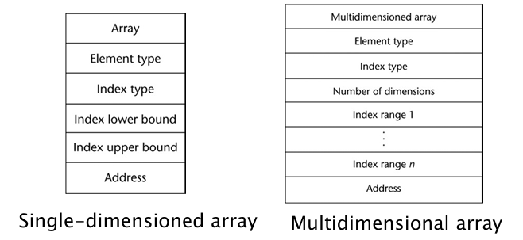
Record Types
A record is a heterogeneous collection of data elements where individual elements are identified by field names. Using dynamic subscripts for records would reduce type checking and performance. It is implemented such that each field in a record is assigned an offset address relative to the beginning record for efficient access. Design issues include:
- What is the syntactic form of references to the field?
- Whether elliptical (shorthand) references are allowed.
Tuple Types
Tuples are similar to records but without named elements. Used in Python, ML, and F# to return multiple values from functions. In Python, tuples are similar to list but immutable. e.g., myTuple = (3, 5.8, 'apple').
List Types
Lists in Lisp and Scheme are delimited by parentheses without commas. e.g., (A B C D) or (A (B C) D). Lists can represent both data and function calls as data (A B C) is simply a list, while as code it represents the function A applied to parameters B and C.
Union Types
A union allows variables to store different type values at different times. Design issue: Should type checking be required? Free unions (C and C++) lack type checking, while discriminated unions (ML, F#) include a type indicator.
Pointer and Reference Types
Pointers have values that consist of memory addresses and a special value, nil. They provide indirect addressing and dynamic memory management. Reference types (C++, Java, C#) offer safer alternatives to pointers.

Design Issues of Pointers
- What are the scope and lifetime of a pointer variable?
- What is the lifetime of a heap-dynamic variable?
- Whether pointers are restricted to specific data types.
- Whether pointers are used for dynamic storage management, indirect addressing, or both.
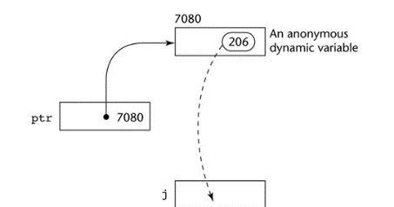
- Whether a language supports pointers, references, or both.

Pointer Operations
- Two main operations: assignment and dereferencing.
- Assignment sets a pointer to a memory address.
- Dereferencing accesses the value stored at that address.
- Example (C++): j = *ptr. C/C++ support explicit dereferencing (*) and address-of (&) operators. void* can point to any type but cannot be directly dereferenced.

Problems with Pointers
- Dangling pointer: A pointer referencing memory that has been deallocated.
- Lost heap-dynamic variable: Allocated memory that is no longer accessible. Can cause memory leakage and unsafe behavior.

Dangling Pointer Prevention Techniques
- Tombstones: Use an intermediate pointer that becomes nil when memory is deallocated (costly in space and time).

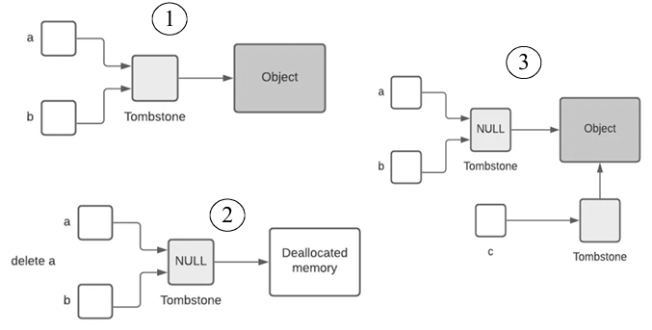

- Locks-and-keys: Use a key–lock system to validate pointer access and prevent invalid references.
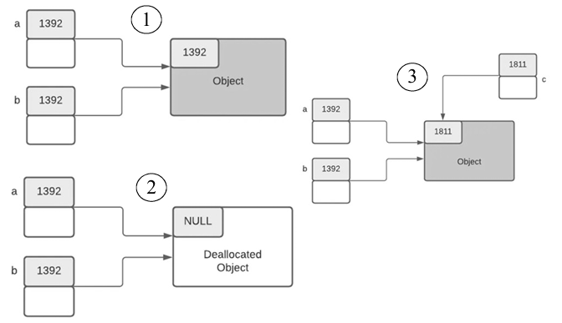

Type Checking
Type checking ensures that operands of an operator are of compatible types. A compatible type is either directly valid for the operator or can be implicitly converted (via compiler coercion) to a valid type.
Strong Typing
- Strong typing means a language strictly enforces type rules to prevent type errors. Like ML and F# are strongly typed.
- Java and C# are mostly strongly typed but allow limited type casting.
- C and C++ are not strongly typed due to weak type checking features like unions.
- Coercion rules can weaken strong typing (e.g., C++ is weaker than ML/F#).

Static Type Checking
Static type checking is performed at compile time before program execution.
Examples: C, C++, TypeScript
int x = 10;
x = "Hello"; // Compile-time error

Advantages
- Detects type errors early.
- Improves reliability and safety.
- Faster execution since no runtime type checks are needed.
- Helps compiler optimization.

Disadvantages
- Less flexible.
- Requires type declarations or type inference.
- Some valid operations may be rejected if they cannot be verified at compile time.

Dynamic Type Checking
Dynamic type checking is performed during program execution (runtime).
Examples: Python, JavaScript, Ruby
x = 10
x = "Hello" # Allowed

Advantages
- More flexible and easier to write.
- Supports rapid prototyping.
- Variables can hold values of different types at different times.

Disadvantages
- Type errors are detected only when the affected code executes.
- Runtime overhead due to type checking.
- May reduce reliability because some errors remain hidden until execution.
Static Type Checking | Dynamic Type Checking
Performed at compile time. | Performed at runtime.
Types are checked before execution. | Types are checked during execution.
Faster execution. | Slower due to runtime checks.
More reliable; catches errors early. | More flexible; errors may appear later.
Used in C, C++, Java, C#. | Used in Python, JavaScript, Ruby.

Name Type Equivalence
Two variables have equivalent types only if they are declared in the same declaration or use the same type name. This method is easy to implement but highly restrictive. It does not treat similar structures as compatible types (e.g., subranges are not compatible with their base types).
In languages like C++, even identical-looking typedef structures are considered different types if they have different names.
typedef struct { int value; } Kilograms; typedef struct { int value; } Centimeters;
Kilograms boxWeight = {50}; Centimeters personHeight = {180};

Structure Type Equivalence
Two variables have equivalent types if their types have identical structures. This approach is more flexible than name type equivalence but harder to implement. Types with the same structure are considered equivalent even if they have different names.
interface Point { x: number; y: number; } interface Vector { x: number; y: number; } let p: Point = { x: 10, y: 20 }; let v: Vector = { x: 5, y: 5 };
p = v // VALID: Under Structural Equivalence because their shapes match.

Chapter 7: Expressions and Assignment Statements

Arithmetic Expressions

Arithmetic expressions are used to perform computations in programs. They consist of operators, operands, parentheses, and function calls. Understanding expression evaluation requires knowing the order of operator and operand evaluation. Many programming languages use the concept of expression evaluation, especially imperative and functional languages. Examples include: C/C++/Java/Python/JavaScript/Pascal/Lisp.

Design Issues in Arithmetic Expressions
Key design issues include:
- Operator precedence rules.
- Operator associativity rules.
- Order of operand evaluation.
- Operand evaluation side effects.
- Operator overloading.
- Type mixing in expressions.
Types of Operators
- Unary Operators: One operand
- Binary Operators: Two operands
- Ternary Operators: Three operands

Feature | Unary Operator | Binary Operator | Ternary Operator
Number of Operands | 1 | 2 | 3
Purpose | Performs an operation on a single operand. | Performs an operation between two operands. | Evaluates a condition and chooses one of two expressions.
General Syntax | operator operand or operand operator | operand1 operator operand2 | condition ? expression1 : expression2
Examples | -x, ++x, x--, !flag | a+b, x*y, a>b | (a>b) ? a : b
Common Use | Increment/decrement, negation, logical NOT. | Arithmetic, relational, logical, assignment operations. | Short-hand replacement for if-else.

Examples

Unary Operator
int x = 5;
int y = -x;
Output:
y = -5

Binary Operator
int sum = 10 + 20;
Output:
sum = 30

Ternary Operator
int max = (a > b) ? a : b;
Equivalent to:
if (a > b)
max = a;
else
max = b;

Can a Ternary Operator Be Nested?
Yes. A ternary operator can contain another ternary operator.
Example:
int largest = (a > b)
? ((a > c) ? a : c)
: ((b > c) ? b : c);
This determines the largest value among a, b, and c.

Operator Precedence Rules
These rules define the order in which operators of different precedence levels are evaluated. Typical precedence levels include:
- Parentheses
- Unary operators
- Exponentiation (**) (if supported)
- Multiplication and Division (*, /)

Addition and Subtraction (+, -)

Operator Associativity Rule
These rules determine the order in which adjacent operators with the same precedence level are evaluated. Typically associativity is from:
- Left to right, except exponentiation (**), which is right to left.

Unary operators may associate right to left (e.g., FORTRAN, APL).

Parentheses can override precedence and associativity rules.

Expressions in Ruby and Scheme
- Ruby: Arithmetic, relational, assignment, array indexing, shift, and bitwise logic operators are implemented as methods, allowing them to be overridden by application programs.
- Scheme (and Common Lisp): Arithmetic and logic operations are performed through explicitly called subprograms (functions). For example, a + b * c is written as (+ a (* b c)).

Conditional Expressions
In C-based languages (e.g., C, C++) conditional expressions use the ternary operator ? :.
For example: average = (count == 0) ? 0 : sum / count;
This is equivalent to:
if (count == 0) average = 0; else average = sum / count;
Operand Evaluation Order
Operands are evaluated as follows:
- Variables: Their values are fetch from memory.
- Constants: Their values may be fetched from memory or embedded directly in machine instructions.
- Parenthesized Expressions: All operands and operators inside the parentheses are evaluated first.
- Function Calls: The function is executed to obtain the operand value.

Side Effects of Operand Evaluation
Functional side effects occur when a function changes a two-way parameter or a non-local variable. Problems arise when a function referenced in an expression modifies another operand of the expression. For example:
a = 10;
b = a + fun(&a); /* assume that fun changes its parameter */

Solutions to Functional Side Effects
- Two common solutions:
  - Prevent functions from having two-way parameters and accessing non-local variables. Advantage: Eliminates functional side effects. Disadvantage: Reduces flexibility due to one-way parameters and restricted access to non-local variables.
  - Define a specific order for evaluating operands. Advantage: Makes expression evaluation predictable. Disadvantage: Limits some compiler optimizations.

Referential Transparency
Referential transparency is a property of a program where an expression can be replaced with its value without changing the program’s behavior. For example:
result1 = (fun(a) + b) / (fun(a) - c); temp = fun(a);
result2 = (temp + b) / (temp - c);
If fun has no side effects, result1 = result2; otherwise referential transparency is violated.

Advantages of Referential Transparency

Makes program semantics easier to understand.

Enables safer reasoning because expressions behave consistently.

Pure functions depend only on their parameters and not on external changing values, as they have immutable state and are referentially transparent.

int x = 5;
int fun(int a) {
x = x + 1; // side effect (modifies global variable)
return a + x;
}
Here, fun(a) depends on and modifies external state (x), so it has a side effect.

How Side Effects Break Referential Transparency
If a function has side effects, replacing expressions may change program behavior.

Example:
result1 = fun(a) + fun(a);
If fun(a) changes a global variable each time it is called, then:
- First call gives one value
- Second call gives a different value
So:
result1 ≠ (2 * fun(a))
This violates referential transparency.

Relationship Between Both Concepts
- Referential transparency exists only when functions are pure (no side effects).
- Functional side effects destroy referential transparency because results depend on execution history or external state.

Overloaded Operators
- Operator overloading is the use of an operator for more than one purpose.
- Some overloading is common and useful (e.g., + for both integers and floating-point numbers) while others can cause problems (e.g., * in C/C++ for multiplication and dereferencing).
- Issues include:
- Reduced compiler error detection (missing operands may not be flagged as errors).
- Reduced readability of expressions.

Type Conversions
- A narrowing conversion converts a value to a type that cannot represent all values of the original type (e.g., float → int).
- A widening conversion converts a value to a type that can represent all values of the original type (e.g., int → float).

Mixed-Mode Expressions and Coercions
- A mixed-mode expression contains operands of different types.
- Coercion is an implicit type conversion performed by the compiler. It reduces the compiler’s ability to detect type errors. In most languages, numeric types are coerced in expressions using widening conversions.
int a = 5; float b = 2.5; float c = a + b;
The compiler performs coercion (int → float)
- Explicit Type Conversion: Known as casting in C-based languages (e.g., (int)angle in C, float(sum) in F#).

Errors in Expressions
Causes include inherent limitations of arithmetic (e.g., division by zero) and limitations of computer arithmetic (e.g., overflow). These errors are often ignored by the run-time system in many languages
Relational and Boolean Expressions
- Relational expressions use relational operators with operands of various types and evaluate to a Boolean value. Different languages use different operator symbols (e.g., !=, /=, <>, .NE., #).
- Boolean expressions have Boolean operands and produce Boolean results.
- In C (before C99), there is no Boolean type; integers are used (0 = false, non-zero = true).

A common issue in C: expressions like a < b < c are evaluated incorrectly due to left-to-right evaluation leading to unintended results.

Short Circuit Evaluation
A short-circuit evaluation is when an expression’s result is determined without evaluating all operands or operators.
Example: (13 * a) * (b / 13 - 1)
If _{a} is zero, there's no need to evaluate _{(b / 13 - 1)}.
Languages like C, C++ Ruby, Perl, and Python use short-circuit evaluation for logical operators like (&&and ||)
Why Short-Circuit Evaluation is Useful
- Improves program efficiency by avoiding unnecessary evaluations.
- Prevents runtime errors (e.g., null pointer dereferencing).
- Ensures safe condition checking in expressions.
- Reduces execution time in complex logical expressions.
- Supports better control flow logic in decision making.
Problems:
- Can cause errors such as array index out of bounds in conditions like:
while (LIST[index] != value) && ( index < length )
Without short-circuiting, LIST[index] may be accessed when index == length, causing an error.
Side effect risk with short-circuit:
(a > b) || (b++ / 3)
If a > b is true, b++ is NEVER executed → b not incremented.
This can cause bugs if side effect of b++ was intended.

Assignment Statements
- General syntax: <target_var> <assignment_operator> <expression>.
- Assignment operators:
  - = in Fortran, BASIC, and C-based languages.
  - := in Ada.
- Overloading = as both assignment and equality operator can cause confusion; C-based languages avoid this by using == for equality.

Conditional Targets
- Some languages (e.g., Perl) allow assignment to conditional expressions.
- Example: ($flag ? $total : $subtotal) = 0
- Equivalent to an if-else assignment:
if ($flag){ $total = 0 }
else { $subtotal = 0 }

Compound Assignment Operators
- A shorthand method for common assignments (introduced in ALGOL, used in C-based languages).
- Example: a = a + b can be written as a += b.

Unary Assignment Operators
- Combine increment/decrement with assignment (C-based languages).
- Examples:
  - ++count: increment then use value
  - count++: use value then increment

Assignment as an Expression
- In C, Perl, JavaScript, assignment returns a value and can be used in expressions.
- Example: while ((ch = getchar()) != EOF) ch = getchar() is carried out; the result (assigned to ch) is used as a conditional value for the while-statement.
- Disadvantage: can introduce side effects and reduce readability.

Multiple Assignments
- Languages like Perl, Ruby, and Lua support multiple assignments.
- Example: ($first, $second, $third) = (20, 30, 40)
- Swapping is also possible: ($first, $second) = ($second, $first)

Assignment in Functional Languages
- Identifiers in functional languages are only names of value. Variables are immutable; re-binding creates a new name/value binding.
- In ML, values are bound using val (e.g., val fruit = apples + oranges).
- In F#, JavaScript let is used, which also introduces a new scope.

Mixed-Mode Assignment
- Fortran, C, Perl, C++ allow assignment between numeric types through implicit coercion.
int x = 10;
float y;
y = x; // int → float (implicit conversion)
- Java and C# allow only widening conversions.
- Ada does not allow assignment coercion.

Subprograms/Functions — design issues + categories
Design Issues for Subprograms
- What parameter passing methods are provided? (e.g., call by value, reference).
- Whether parameter types are checked and if type checking is done at compile time or runtime.
- Whether local variables are static, stack-dynamic, or heap-dynamic (lifetime and storage binding).
- Whether subprograms can be defined inside other subprograms.
- Whether subprograms are allowed to produce side effects (modify non-local variables).
- Whether a subprogram returns a value (function) or not (procedure) and how multiple values are handled.
- Whether overloading or generic subprograms are supported.
- What is the order in which actual parameters are evaluated before being passed.
- Whether closures are supported?

Categories of Subprograms:
- Procedures: Perform actions with no return value (e.g., void functions in C).
- Functions: Subprograms that return a value and may or may not produce side effects.
- Methods: Subprograms associated with objects/classes in OOP languages.

i) What kind of binding is used for the function call func_ptr()?
The function call func_ptr() uses Late Binding (also frequently referred to as Dynamic Binding or Run-time Binding).

ii) Explain how the compiler determines the function to be called.
For a function pointer, the exact function to be executed is not determined by the compiler at compile-time. Instead, it is resolved during run-time. Here is exactly how the process works:
- At Compile-Time: The compiler sees an indirect function call. It checks the type signatures to ensure safety (verifying that func_ptr is designed to point to a function taking no arguments and returning void). Instead of hardcoding a direct jump to a specific function's memory address, the compiler generates machine instructions to look inside the func_ptr variable.
- At Run-Time: When the program hits func_ptr();, the CPU reads the value currently stored inside that pointer variable. Because the code previously assigned the address of display to the pointer (void (*func_ptr)() = display;), the pointer holds the starting memory address of the display() function.
- Execution: The program executes an indirect jump to the memory address it just retrieved, successfully calling the display function.

